Toxoplasmosis
is a parasitic disease caused by Toxoplasma gondii. an obligate intracellular protozoan parasite in the phylum Apicomplexa. Infections with toxoplasmosis usually cause no symptoms in adult humans. Occasionally there may be a few weeks or months of mild flu-like illness such as muscle aches and tender lymph nodes. In a small number of people, eye problems may develop. In those with a weak immune system, severe symptoms such as seizures and poor coordination may occur. If infected during pregnancy, a condition known as congenital toxoplasmosis may affect the child.
The major forms of the parasite are:
Oocysts (containing sporozoites), which are shed in the feces.
• Tachyzoites, rapidly multiplying organisms found in the tissues.
• Bradyzoites, slowly multiplying organisms found in the tissues.
• Tissue cysts: walled structures, often found in the muscles and central nervous system (CNS), containing dormant T. gondii bradyzoites
Toxoplasma gondii exists in three forms
All parasite stages are infectious
TACHYZOITES
TISSUE CYSTS
BRADYZOIT
OOCYSTS
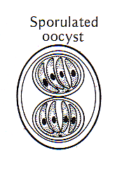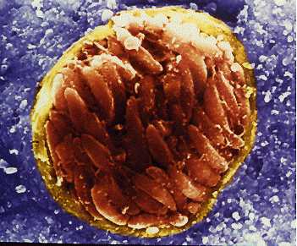

Tachyzoite stage:
Rapidly growing stage observed in the early stage of infection.
(Acute phase) habits in the body fluid.
Crescent-shaped. One end is more pointed than the other sub terminal placed nucleus.
Asexual form.
Multiplies by endodyogeny

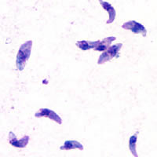

Bradyzoites
Are slow-growing stage inside the tissue cysts.
Bradyzoites mark the chronic phase of infection.
Bradyzoites are resistant to low pH and digestive enzymes during stomach passage.
Protective cyst wall is finally dissolved and bradyzoites infect tissue and transform into tachyzoites.
Bradyzoites are released in the intestine and are highly infective if ingested.

Oocysts in the feces of cat:
Cat ingests tissue cysts containing bradyzoites.
Gametocytes develop in the small intestine.
Sexual cycle produces the oocyst which is excreted in the feces.
Oocysts appear in the cat’s feces 3-5 days after infection by cysts.
Oocysts require oxygen and they sporulate in 1- 5 days
Host
T. gondii can be found anywhere in the world and infects all warm-blooded vertebrates, including mammals and birds.
Infects animals, cattle, birds, rodents, pigs, and sheep and humans (intermediate hosts)
-Toxoplasmosis is leading cause of abortion in sheep and goats.
-Intracellular parasite.-
Final host (Felidae family, cat).
Life cycle:
T. gondii undergoes an asexual reproductive cycle in all species. The tissue cyst or oocyst wall is dissolved during digestion, releasing bradyzoites or sporozoites, which enter the lamina of the small intestine and begin to multiply as tachyzoites. The tachyzoites can disseminate to extraintestinal tissues within a few hours of infection, by the lymph and blood. They can enter nearly any cell and multiply; the host cell eventually ruptures and the released tachyzoites enter new cells. As host resistance develops, approximately 3 weeks after infection, the tachyzoites begin to disappear from the visceral tissues and form “resting” bradyzoites within tissue cysts. These cysts are found most often in the skeletal muscles, brain and myocardium. They generally do not cause a host reaction and can persist for life.
In Felidae, the definitive hosts, the parasites undergo a sexual cycle of replication. After ingestion, some of the bradyzoites multiply within the epithelial cells of the small intestine. After numerous cycles of asexual reproduction, these bradyzoites initiate the sexual cycle (gametogony), which results in the formation of an unsporulated oocyst. The oocyst is excreted in the feces and sporulates in the environment. Sporulation takes approximately 1 to 5 days under ideal conditions, but may take up to several weeks. After sporulation, the oocyst contains two sporocysts, each with four sporozoites. Cats usually shed oocyts for one to two weeks
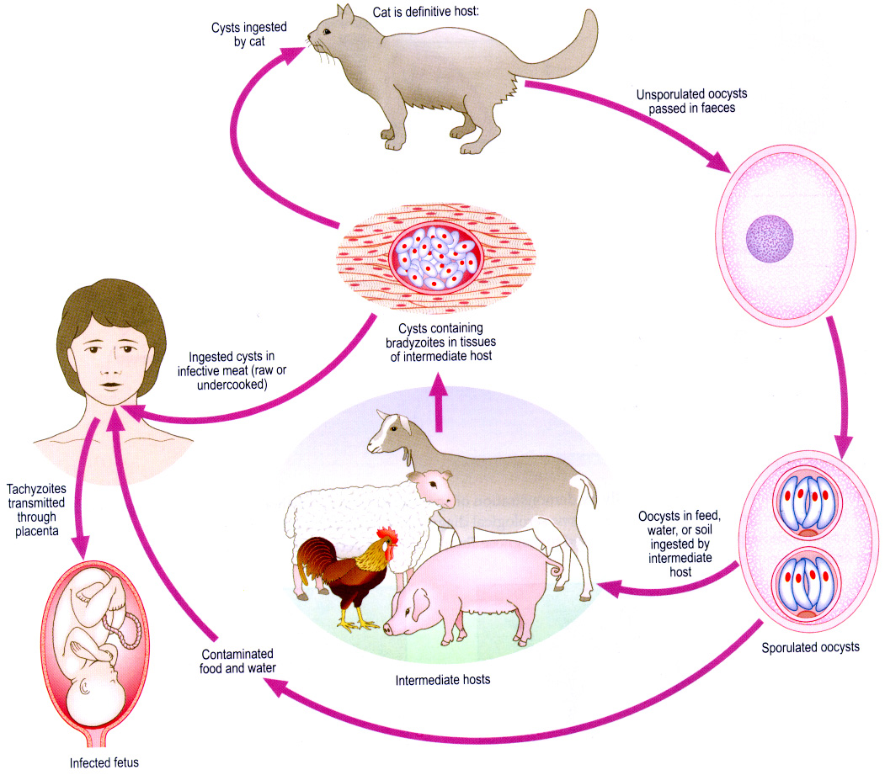

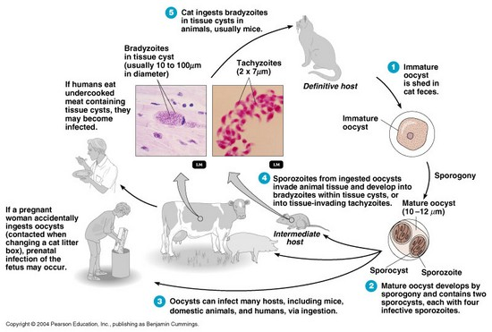

Toxoplasma gondii in the lung of a Giant panda.Arrow: macrophagescontaining tachyzoites
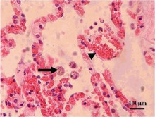

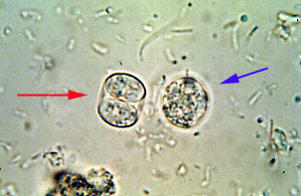
Toxoplasma gondii An unsporulated oocyst (blue arrow) and a sporulated oocyst (red arrow) seen at high power (40 X). It takes 2 to 3 days for the oocyst (10 µm) to sporulate
Transmission
1-humans, can become infected when they eat raw or undercooked tissues containing tissue cysts or, occasionally, tachyzoites.
2-Both herbivores and carnivores may ingest infective oocysts in food or water, inhaling oocysts, or come into contact with contaminated soil.
3-T . gondii can cross the placenta in some species, particularly sheep, goats, humans and small rodents.
4-Transmission in transfused blood or transplanted organs is possible but rare. Flies and cockroaches can act as mechanical vectors.
5-Toxoplasmosis is the most common work-related parasitic infection in laboratory workers. Infections can be acquired by accidental inoculation, inhalation or ingestion. The source of infection may be blood or blood products, semen, feces or tissues

Diagnosis:
1-Toxoplasmosis can be diagnosed by direct observation of the parasites in tissues, including bronchoalveolar lavage material and lymph node biopsies.
2-Immunohistochemical staining and electron microscopy are also used.
3-T. gondii can also be isolated from muscle, brain, blood or other body fluids, using cell culture or mouse inoculation. Computed tomography techniques are sometimes helpful in cases of cerebral toxoplasmosis and ultrasound may be used in the fetus.
4-TheIFA and ELISA tests are used most often in humans.
5-Other serologic tests include the Sabin-Feldman dye test.
6-Indirect hemagglutination, latex agglutination.
7- modified agglutination and complement fixation.
8- A toxoplasmin skin test is sometimes used in epidemiologic studies.
9-IgM-specific tests are performed when it is important to know the time of infection,e.g. in a pregnant woman. A negative IgM test strongly suggests that the infection was not recent, but a positive IgM test is difficult to interpret; Toxoplasma-specific IgM can be found for up to 18 months after the acute infection and false positives are common.
10- PCR techniques can be helpful, particularly for detecting congenital infections in uterus.

